

Experiment: Unity Navigation System

Introduction:
The ability for a game object to move intelligently through a complex scene is essential for most, if not all, game-play activities. How would an enemy follow the player through a maze? How would a guard patrol around a building or along a path? What happens when a level has steep hills or impassable rivers? A navigation mesh is employed to solve these problems. Luckily, Unity 3D does all the heavy lifting for us! All we need to do is provide the pathing agent a target location.

This experiment will provide a walk-through of how to:
- Set up a navigation mesh.
- Add blocking objects.
- Add navigation agents.
- A simplistic -point system.

Setup
For this experiment, start with a fresh new scene. We will be creating a small terrain with a few cubes strategically placed as path blockers. Our pathing agent will be represented by a cylinder. Textures, materials, effects and any other atheistically pleasing features are excluded. This will help eliminate distractions and allow us to focus on the core functionality.
Before starting this experiment, make sure to meticulously read the reference links. They provide thorough details on every attribute of the navigation mesh tool and pathing agent.

Terrain
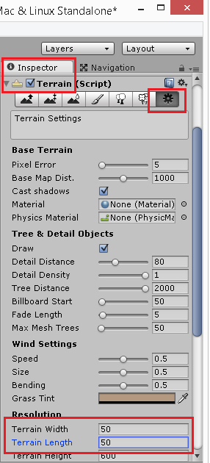
- Create a Terrain game object. Trim its size down to 50 for the width and length.

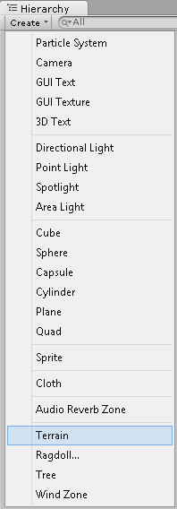

Note: You may want to add a Directional Light to help brighten your scene.

Note: You are free to add a material of your choice. The screenshots won’t show a material.

Camera
- Select the main camera game object and orient it such that it views the terrain from a top-down perspective.
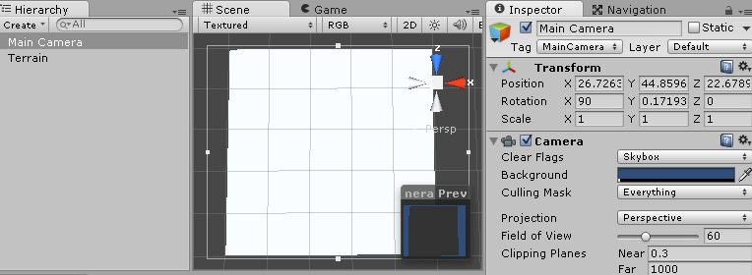

Path Blockers
- Add a cube game object and rename it to “PathBlocker”
- Set its material to none. It should look magenta.
  - Note: You are free to add a material of your choice. The screenshots won’t show a material.
- Duplicate that cube at least three times and place them where desired.
- Ensure they are intersecting with the terrain.

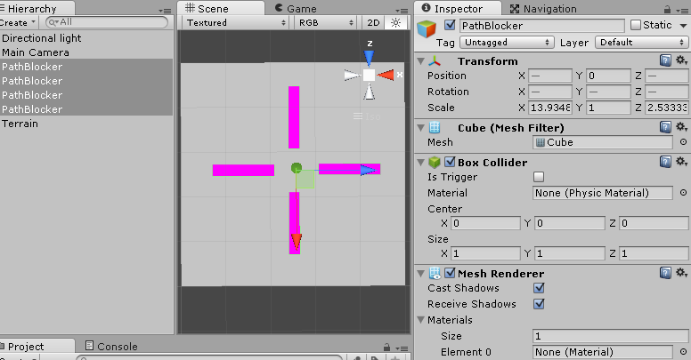

Navigation Mesh
- From Unity’s main menu bar, select the “Window” option then “Navigation”
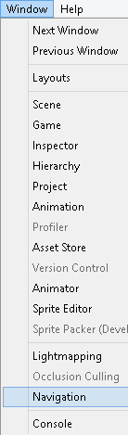

- A new “Navigation” window should open next to the “Inspector” window.
- If not already selected, from the navigation window select the “object” sub-tab.
- Select the “PathBlocker” objects in the “Hierarchy” window.
- From the navigation window check the box “Navigation Static”
- Doing so makes Unity’s navigation mesh algorithm aware of those game objects.
- With those same game objects selected, set the “Navigation Layer” to “Not Walkable”
- This simply denotes them as impassable blocking objects.
- Review the terrain and ensure the default properties are setup correctly.

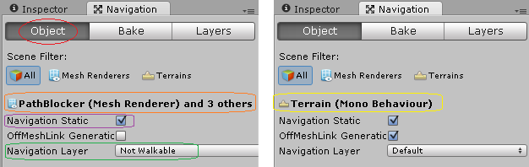

- From the navigation window select the “bake” sub-tab then the “bake” button.

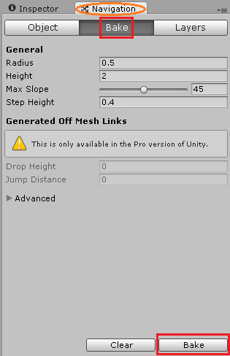

- If the “Show NavMesh” is checked in the “Scene” view, the terrain should now display a blue-ish set of connected polygons.
- The “PathBlocker” objects should have cut outs around them. This highlights the objects excluded from the mesh.

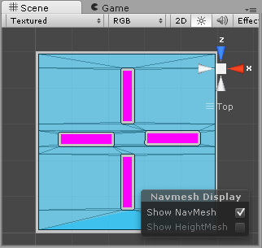

Simple NavPoint
- Create a new sphere game object and name it “NavPoint”.
- Set its material to none or select one of your choice.
- Set its collider to be a trigger by checking the “Is Trigger” property.
- This will allow for collision detection without actually blocking our path.
- Scale it to an appropriate size.
- Add a new C# script component named “NavPoint”
  - Note: You do not need to change or add script to it. It is used to associate a class type with this game object.
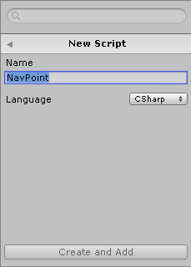

- Duplicate it at least three times and place them around the scene as desired.
- These objects represent the locations where the agent will visit when pathing. Meaning, the agent will move from one NavPoint to the next.

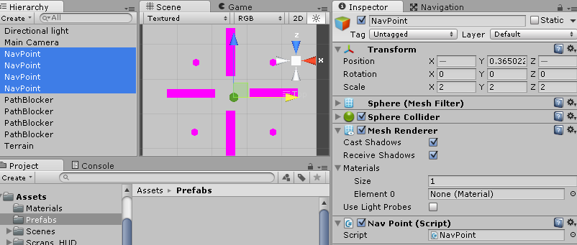

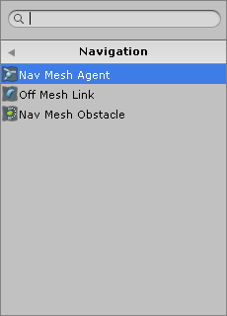
Navigation Agent
- Create a new cylinder game object and name it NavAgent.
- Set its material to none or select one of your choice.
- Add a “Rigid Body” component to it.
  - Turn off (uncheck) the “Use Gravity” option
- Add a “Nav Mesh Agent” component to it.
  - NOTE: You may need to adjust the component’s “Base Offset” or “Height” to properly align the agent with the cylinder visual.
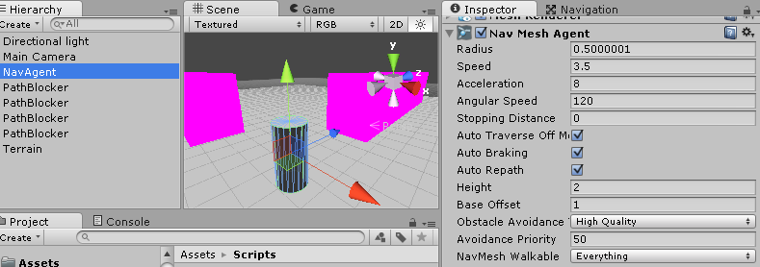

- Add a new script component to it named “NavAgent”
- Open the script.
- We need a reference to our navigation mesh agent component so we can tell it where it needs to travel.
  - Declare a variable of type NavMeshAgent.
- Next, we need to store a list of of the navigation points we placed in the scene.
  - Declare an array variable of type NavPoint.
- Finally, we need a means to track which NavPoint the agent is heading towards.
  - Declare an integer variable and name it something similar to navIndex.
NavMeshAgent myNavAgent;
[SerializeField] NavPoint[] myNavPoints;
int navIndex = 0;

Note: For the compiler to find the class “NavMeshAgent” you may need to use your IDE(Integrated development environment aka visual studio) to “resolve" the missing using directive.

In the “Start” function of this script…
- use the “GetComponent” function to populate our NavMeshAgent reference variable.
void Start()
{
myNavAgent = GetComponent<NavMeshAgent>();
}

- Now create a new function named “FindDestination” which returns nothing (void) and accepts no parameters. Inside this function...
- Using the “navIndex” variable to access an element in the array.
- The position, from the transform, is used as a new destination point.
- Assign it to a Vector3 local variable.
- Call the “SetDestination” function from the navigation agent variable and pass it the vector3 local variable.
- This function is the key to telling our agent what location to visit.
  - NOTE: It accepts any 3D position and is not limited to our NavPoint positions.

void FindDestination()
{
Vector3 newTravelPosition = myNavPoints[navIndex].transform.position;
myNavAgent.SetDestination( newTravelPosition );
}

Now call this at the bottom of the “Start” function’s body.
This will cause the navigation agent to immediately start pathing when the game is played.

void Start ()
{
myNavAgent = GetComponent<NavMeshAgent>();
FindDestination();
}

- Create a new function named “OnTriggerEnter” which returns nothing (void) and accepts no parameters. Inside this function increment the navigation index by one. This moves it to the next item in the navigation point array.
- At some point, the agent will visit all the navigation points. We need to detect and handle when it has reached the end of the list.
- Add an if-statement which checks if the index variable is greater than or equal to the length of the array. If it is, set the index back to zero.
- Call the “FindDestination” function so the position of the new navigation point will be assigned.

void OnTriggerEnter()
{
++navIndex;

if ( navIndex >= myNavPoints.Length )
navIndex = 0;

FindDestination();
}

At this point you are almost ready to go! Switch back to Unity and let it compile. Watch for any errors or warnings. If there are none, the last thing we need to do is use the Unity UI to set the NavPoints for the NavAgent.

In the Unity UI select the NavAgent in the Hierarchy panel so we can inspect the NavAgent’s component. In the Inspector panel scroll down until you can see the NavAgent script component. See screenshot below.
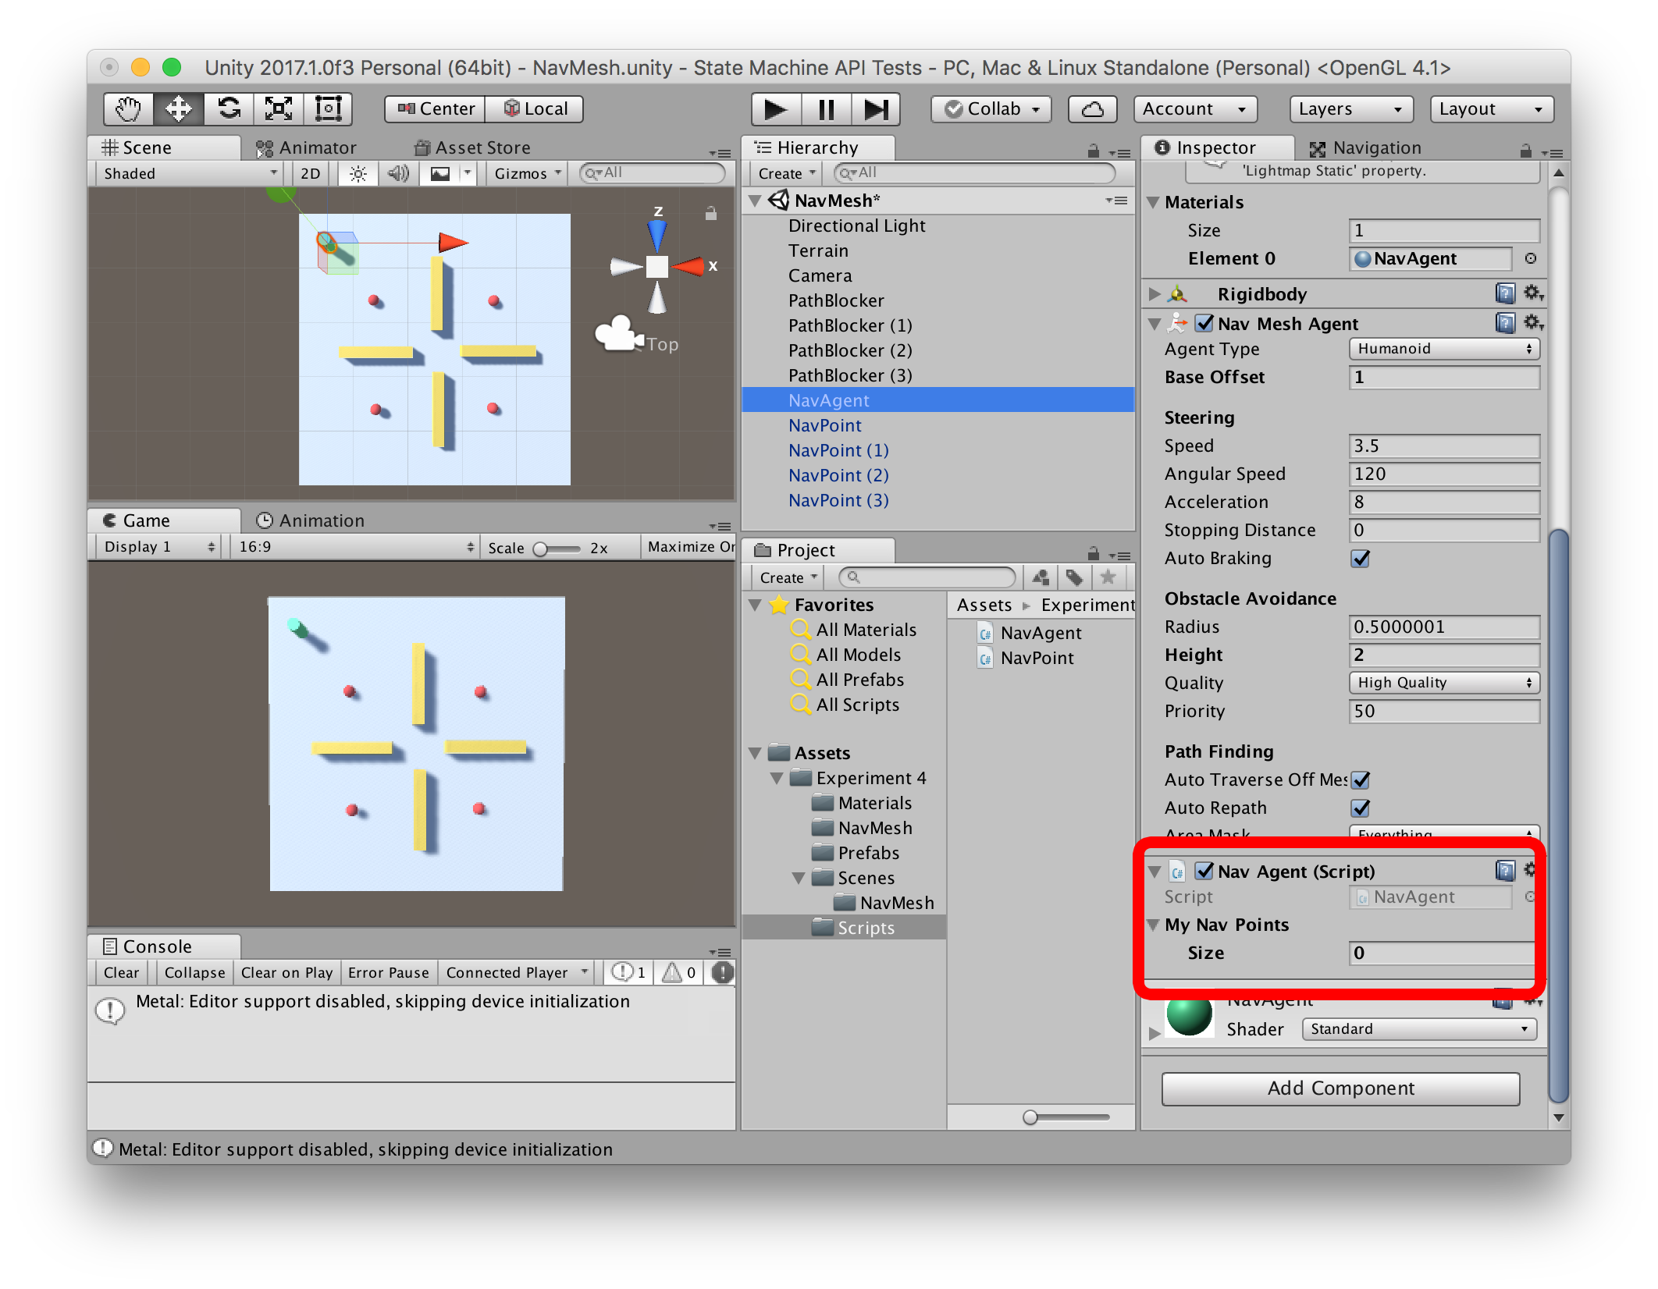

Notice that the NavPoint array is visible in the Inspector with a default size of 0. In the Inspector, change the size field to 4 and 4 slots should appear below the Size field. Drag-n-drop the 4 NavPoint objects (one at a time) from the Hierarchy panel to the slots. This will set those specific NavPoints in the script’s NavPoint array.

It should look like the screenshot below when you are done.
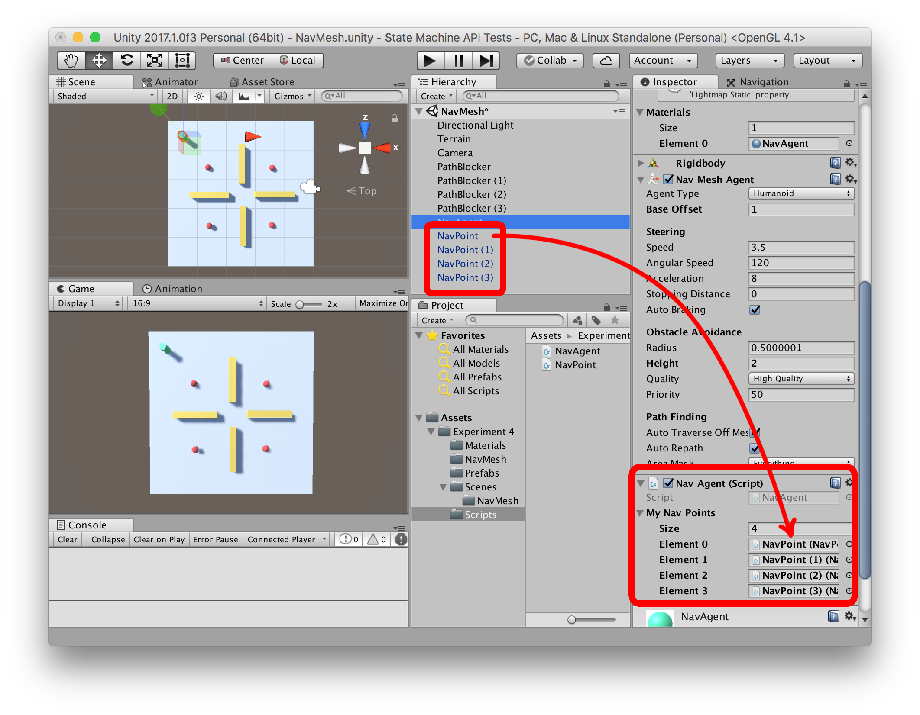

Once all of the NavPoints have been set, hit play and watch your agent travel from navigation point to navigation point. While running, select the Navigation tab. This should turn on the Navigation debug view where you can see the NavMesh and additionally, when the NavMeshAgent is selected, the path the NavMeshAgent is currently following.

Submission:
This assignment’s submission is a screenshot of the working project. Submit the screenshot to the FSO assignment page in the Upload section.
Screenshot must include:
- A clear view of the entire scene in the Scene view and the Game view
- The Hierarchy view with the game objects visible
- The Project view with the folder with the scripts selected so that the script for this assignment appear in the Assets view
- The Navigation tab selected so that Navigation debug view is on in the Scene view
- The NavAgent is selected
- The NavMesh and the path that the NavMeshAgent is following are visible
- The project is running
See the screenshot below for an example of a 100% submission.
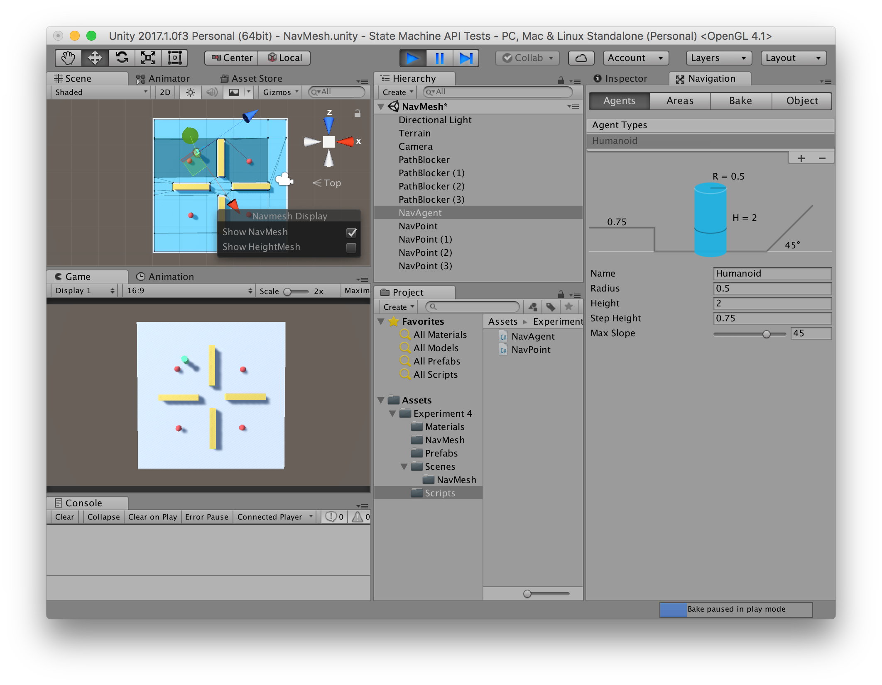

Conclusion:

This is just a rudimentary example of how to use Unity’s navigation system. To fully understand the system’s capabilities and limitations, you will need to do some experimenting on your own. Don’t be afraid! If something breaks, just hit undo, revert to a backup, or start over from scratch. Try experimenting with different NavPoint positions and counts and also adjusting the NavMeshAgents steering parameters. NavMeshAgents can be used for a walking motion but also for a vehicle-like motion as well.

Remember that the Agent can be given any destination location in the scene at any time. You are not limited to the approach this document took. For example, try moving the agent to the location where the mouse has clicked. In fact, Unity provides you the exact script to do just that!

https://docs.unity3d.com/530/Documentation/ScriptReference/NavMeshAgent.SetDestination.html

